St. Pius Family Halloween Night
Tuesday October 31st, 5pm to 7pm
Church Parking Lot and Religious Education Building

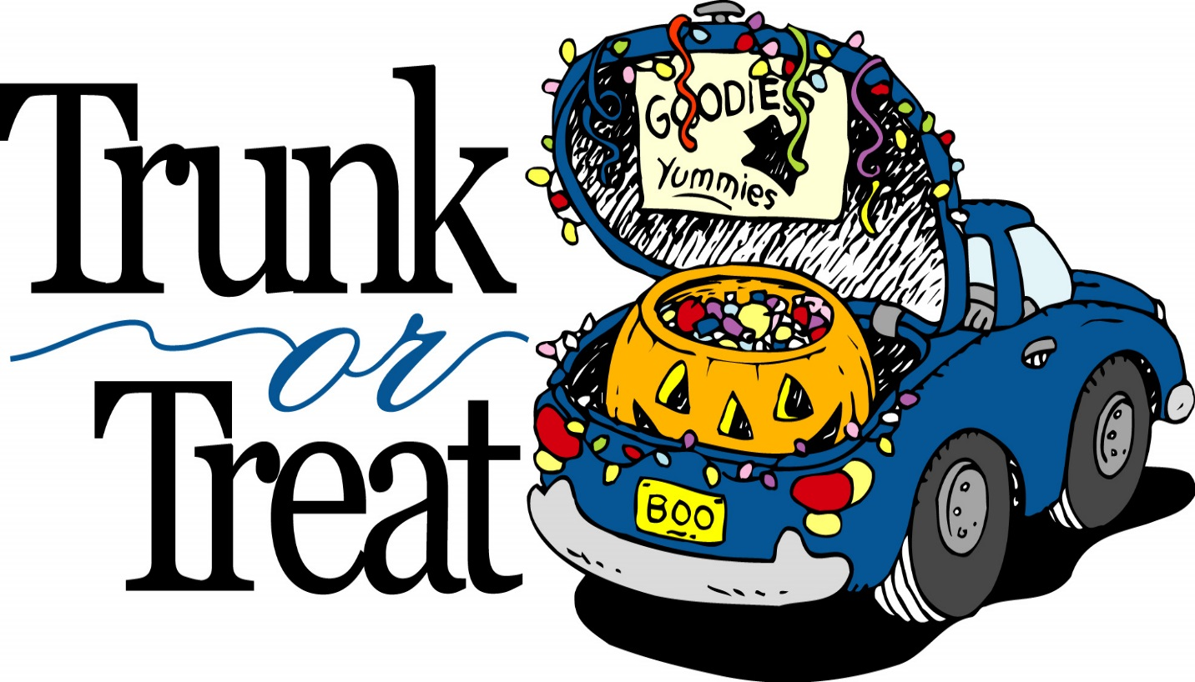
We will have our car in Trunk or Treat___________ Name_____________________________________
Phone Number______________________________
Number of children attending__________________
I would like to help with set-up_________________
I can bake goodies for the party_________________
I can volunteer to help with the games___________

Questions, call Rebecca Gallerizzo at 508-394-0709

