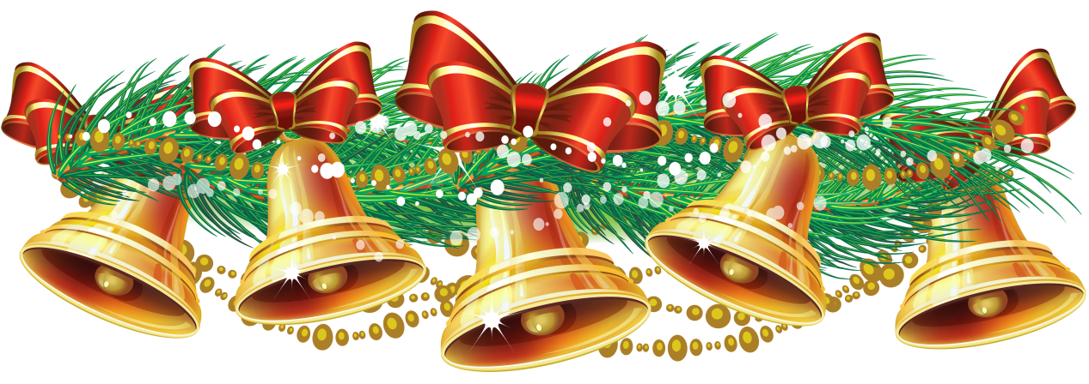

**St. Pius X Church**

**Christmas Fair**

**Saturday, November 20th**

**8:30 am to 2:30 pm**

**Have a muffin or donut early at our Noel Café**

**Lunch served from 11:00 am, Check out our new menu**

**Try our new and delicious menu!**

**SCRATCH TICKET CHRISTMAS TREE RAFFLE**

Come and browse our tables with an assortment of fun items. Jingles Jewelry Corner, North Pole Crafts, Kris Kringles’ Knitted items, Touch of Elegance Evergreens offers Christmas swags, bows and more,

Holly Tree Bakery baked goods, Mrs. Claus’ Kitchen for jams and jellies, brown breads and baked beans, and dog biscuits . Rudolph’s Rada boxed knives,

Dancer’s Wine and Dine and other raffles!

Don’t forget “Santa’s Sack of Treasures”…gently used items and books

and our Santa’s Silent Auction!!

**Shhh! Don’t tell Santa, Mrs. Claus and helper Cookie the Elf will be on hand to help your children to make Christmas ornaments for their trees,. Every child will get cookies and candy canes! Special Raffle just for children too!**

**PARISH LIFE CENTER, STATION AVE.**

**SOUTH YARMOUTH**

**SPONSORED BY THE ST. PIUS X WOMEN’S SOCIETY**